**Updating the Proxy Setting for Maven:**

1. Open Settings.xml from Maven bin folder

Location: File will located in ‘conf’ folder inside maven bin downloaded from the internet

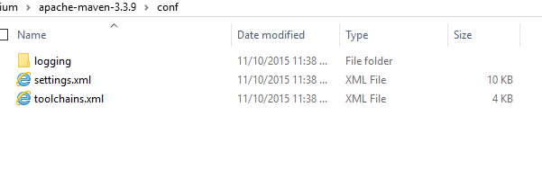

1. Update the Proxy configuration

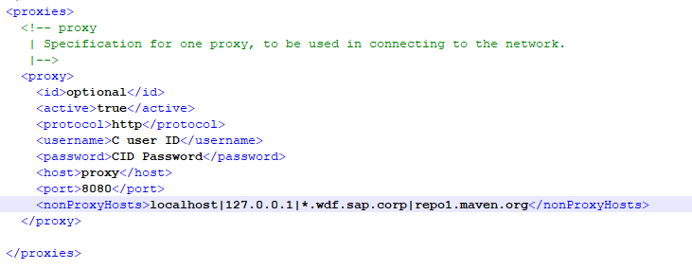

1. Update Maven Global settings.xml file location in Eclipse

Eclipse Path: Windows->Preferences->Maven->User Settings->Global Settings

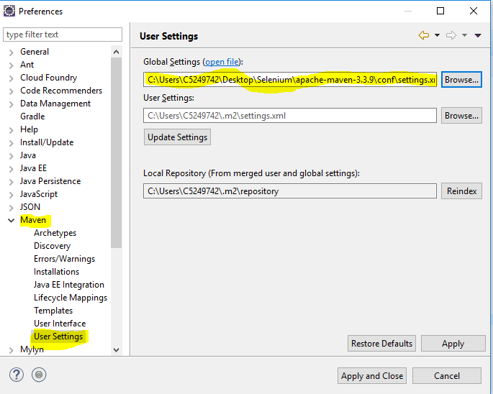

1. Apply and close. Restart the Eclipse

**Eclipse Proxy setup:**

1)Select Active Provider to manual in Network Connectsion

Path: Window->Preferences-> General->Network Connections

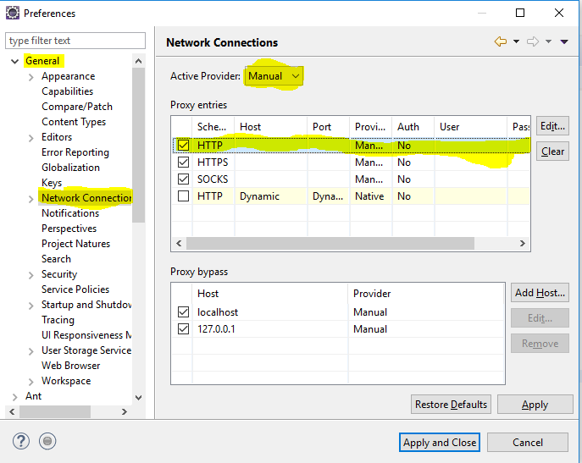

2) Update the Http Protocol with proxy details

